-- QUERY 29: HOW TO FIND THE LIST OF ALL EMPLOYEES WITH UNKNOWN SALARY VALUES AND REPLACE SUCH SALARY VALUES WITH 10000 ?
UPDATE EMPLOYEE_INFO SET EMP_SAL = 10000 WHERE EMP_SAL IS NULL
SELECT * FROM EMPLOYEE_INFO

-- QUERY 30: HOW TO FIND THE LIST OF ALL EMPLOYEES WITH 10000 SALARY VALUE AND DELETE OR REMOVE SUCH EMPLOYEES FROM THE TABLE?
DELETE FROM EMPLOYEE_INFO WHERE EMP_SAL = 10000
SELECT * FROM EMPLOYEE_INFO

DELETE FROM EMPLOYEE_INFO
SELECT * FROM EMPLOYEE_INFO

TRUNCATE TABLE EMPLOYEE_INFO
SELECT * FROM EMPLOYEE_INFO

-- QUERY 31: HOW TO ADD NEW COLUMN TO EXISTING TABLE?
ALTER TABLE EMPLOYEE_INFO ADD EMP_LOCATION VARCHAR(30)
SELECT * FROM EMPLOYEE_INFO

-- QUERY 32: HOW TO MODIFY THE STRUCTURE OF EXISING COLUMN IN THE EXISTING TABLE?
ALTER TABLE EMPLOYEE_INFO ALTER COLUMN EMP_LOCATION VARCHAR(3000)

-- QUERY 33: HOW TO REMOVE AN EXISING COLUMN FROM THE EXISTING TABLE?
ALTER TABLE EMPLOYEE_INFO DROP COLUMN EMP_LOCATION

-- QUERY 34: HOW TO REMOVE THE TABLE FROM DATABASE?
DROP TABLE EMPLOYEE_INFO

-- QUERY 35: HOW TO REMOVE THE DATABASE FROM THE SERVER (INSTANCE)?
USE MASTER
GO
DROP DATABASE EMPLOYEEDB1
CLIENT - SERVER ARCHITECTURE

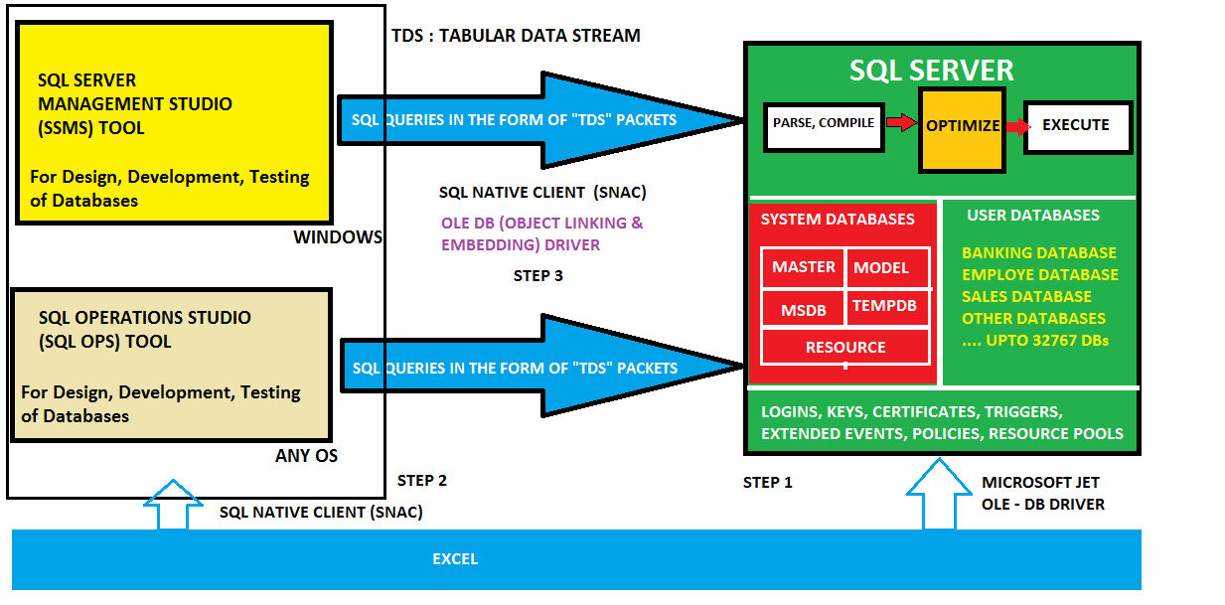

CLIENT (SSMS) COLLECTS THE QUERIES, EMBED THEM INTO "TDS" PACKETS. TABULAR DATA STREAM PACKETS. THESE PACKETS ARE ENCRYPTED [SECURED] AND TRANSFERRED TO THE SERVER USING PROVIDERS (DRIVERS).

THE TDS PACKETS ARE SENT TO SERVER. SERVER "COMPILES" THE CONTENT IN TDS PACKET. EXECUTES. THE RESULT IS SENT TO THE CLIENT (SSMS) IN THE FORM OF TDS PACKETS. DEFAULT PACKET SIZE : 4096 BYTES.

THE PROCESS OF EMBEDDING THE QUERIES INTO TDS PACKETS IS PERFORMED BY USING "PROTOCOLS"

COMPILATION : TO CONVERT FROM HIGH LEVEL SQL LANGAUGE CODE TO MACHINE CODE.

